Appendix 3: Flowchart – Child in Police Custody
Flowcharts from Home Office- Concordat on Children in Custody
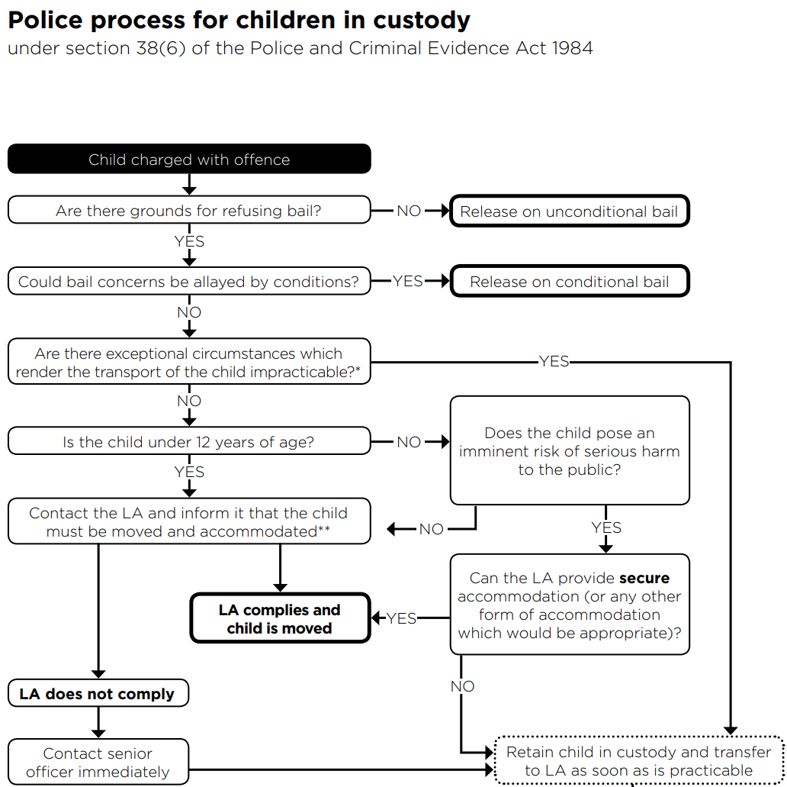

* Circumstances which would render transfer impracticable do not include the availability of Local Authority accommodation, the nature of accommodation offered by the Local Authority, the child’s behaviour, nature of offence, or the availability of transport.
** Custody officers should ensure that the Local Authority is provided with all relevant information about the child and the offence for which they are charged, including reasons for the denial of bail.

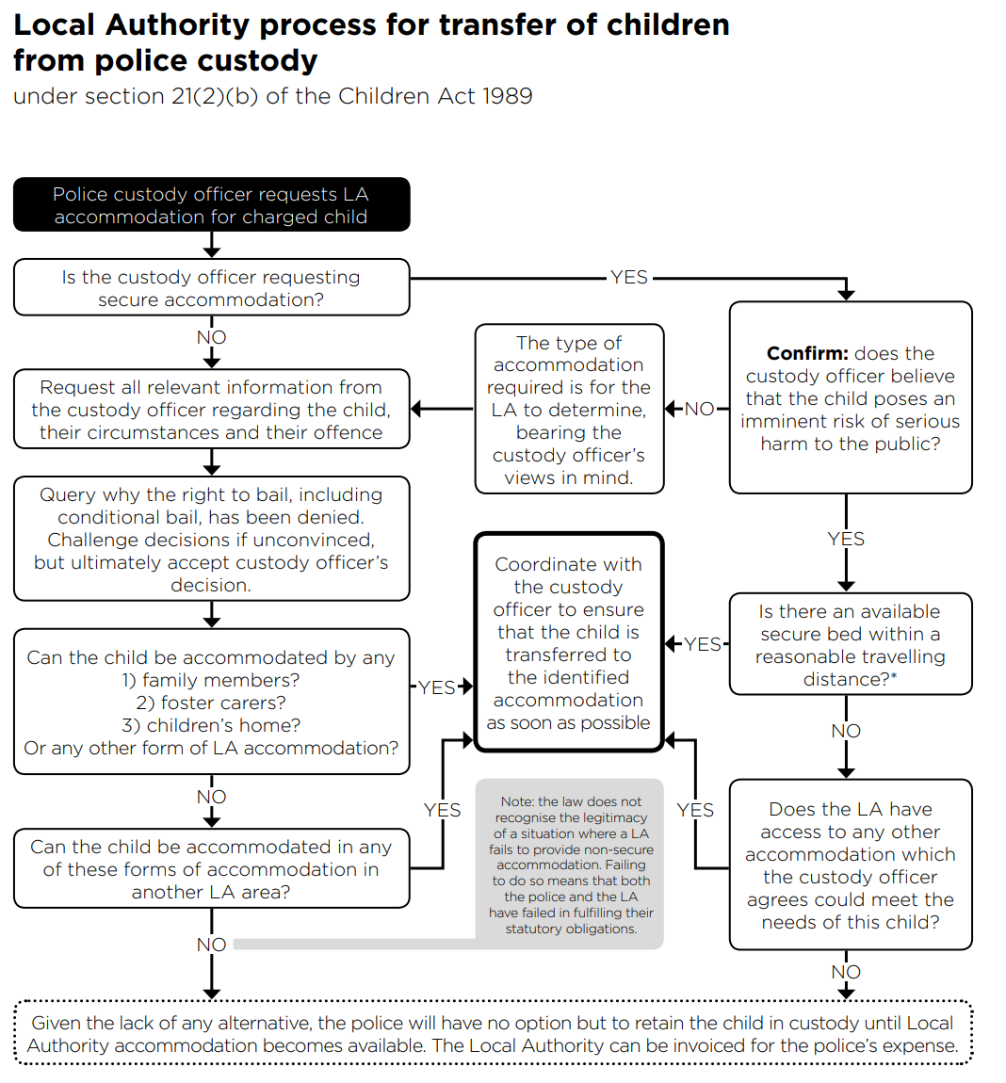

* A reasonable travelling distance would be one which allows the child to be transferred without preventing them having a sensible amount of sleep in advance of their court appearance.

